
BMS College of Engineering
Department of Information Science and Engineering
Capstone Project – AY- 2022-2023
Batch No: 25 | Project Title: Air quality monitoring, forecasting and controlling system using IoT and Data Science

Team Members
SL.No. | Name of the Student | USN
1. | Prateek M Gummaraju | 1BM19IS117
2. | Ruchi Agarwal | 1BM19IS133
3. | Samartha S | 1BM19IS219

Guided by:
Prof Pallavi B (Assistant Professor)

Problem Statement

With 7 million deaths worldwide attributed to air pollution each year, it is currently thought to be the greatest environmental health danger on the planet. Air pollution causes and aggravates a wide range of diseases like asthma, cancer, heart disease etc.
Air pollution is increasing rapidly today, especially in urban and industrial areas primarily due to vehicular emissions, manufacturing facilities and industries accumulating a large number of dangerous pollutants. Due to the rising levels of air pollution and its adverse effects, there is a great need to implement effective air quality monitoring systems that are accurate and cost effective.

Aim

The aim of this project is to successfully build a low cost, IOT based system using Arduino and various sensors that not only monitors the current air quality, but also has the ability to forecast the future predictions and also provide suggestions on how to control the pollution and protect human beings and other living organisms from the harmful pollutants.

The Executive Summary

We will be building an entry level outdoor Air Quality Monitoring System which will give the ppm concentration of various pollutants such as Carbon Monoxide, Nitrogen Dioxide, Sulphur Dioxide, PM 2.5, PM 10, etc. We will also be giving the WHO recommended limits of these concentrations.
We will be calculating the Air Quality Index according to the WHO standard as well.

After intensive research, we have decided on using the following components to build the IoT device:

Sl. No. | Component
Basic Components
1 | Arduino Uno
2 | Breadboard
3 | WiFi module
4 | Jumper Wires
5 | Comparator
6 | Adjustable potentiometer
7 | Resistor set
8 | Capacitors
Sensors
1 | MQ131 Ozone sensor
2 | MQ135 Air Quality sensor
3 | PM 2.5 Particle sensor
4 | MQ7 CO sensor
5 | DHT11 sensor
6 | 110-602 SO2 Sensor
7 | mics-6814

The primary task will be to build the IoT system consisting of the aforementioned components.
Once the IoT is built, we will be using it to collect data. The data will be logged on to ThingSpeak Server and converted to CSV file and downloaded. The data will then be added to the existing dataset to train the model.

Once the model is trained, it will be uploaded to the ThingSpeak server. By doing this, we will be able to display both; the real time data as detected by the IoT system (when the system is available) and the forecasted prediction when the system isn’t available.

We will also be comparing it with the recommended limit given by WHO and suggesting a few tips that can be taken to prevent the air quality from affecting people. We also plan to send alerts to help people suffering from asthma and diseases that are triggered by air pollution.

We think this will be a helpful project for college and the community in general. It will help people understand the air quality around them and our actionable steps will help them take preventive measures. The students of our college as well as the general public can access all the information via the web application that we intend to build.

Diagram Depicting the Solution Concept

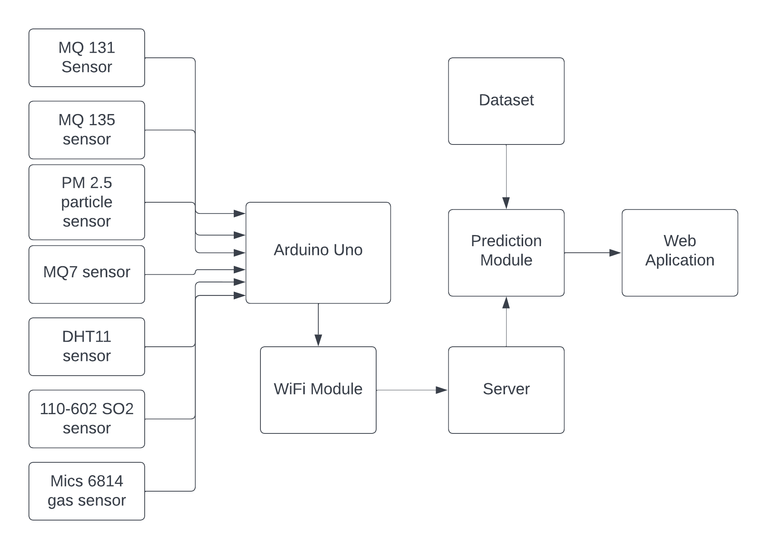

Status

We have successfully completed the research phase of our project. We have thoroughly studied various research papers and understood the various methods in which a similar system has been implemented and the pros and cons of each of those systems. We aim to overcome the challenges that were faced and also add additional functionalities and features to our system.
After the detailed research, we along with our guide have come up with a detailed plan as to how we will proceed with our project henceforth. The next step of our project is to procure the necessary components required to build the IoT device.

Objectives

While researching about the current products in the market, we realized that the 3 main reasons the Air Pollution Monitoring systems haven’t been adopted by every organization are:

- High Costs
- Low Awareness
- Bulky Equipment
As part of our project, we aim to solve these 3 issues mainly.

- Build an IoT system to monitor Air Quality:
a) Monitor Concentrations of No2, So2, O3 PM 2.5 and PM 10
b) Measure AQI
- Build a model to predict the Air Quality in the near future, using the output of the IoT system as input.
- Build a website to display the real time findings.
- Provide analytics on the website, such as the maximum recommended limit and the current concentration.
- Provide measures to improve Air Quality.
- Provide safety measures.

Budget

Sl. No. | Item | Cost per component | Quantity | Total cost
Basic components
1 | Arduino Uno | 600 | 1 | 600
2 | Breadboard | 100 | 2 | 200
3 | WiFi module | 150 | 1 | 150
4 | Jumper Wires set | 100 | 2 | 200
5 | Comparator | 20 | 10 | 200
6 | Adjustable potentiometer | 50 | 2 | 100
7 | Resistor set | 100 | 1 | 100
8 | Capacitors | 10 | 10 | 100
Basic components total |  |  |  | 1650
Sensors
1 | MQ131 Ozone sensor | 1800 | 1 | 1800
2 | MQ135 Air Quality sensor | 150 | 1 | 150
3 | PM 2.5 Particle sensor | 400 | 1 | 400
4 | MQ7 CO sensor | 120 | 1 | 120
5 | DHT11 sensor | 100 | 1 | 100
6 | 110-602 SO2 Sensor | 2500 | 1 | 2500
7 | mics-6814 | 5000 | 1 | 5000
Sensors total |  |  |  | 10070
Grand Total |  |  |  | 11720

Gantt Chart

